**COMPARISON BETWEEN KERNEL FUNCTIONS OF SUPPORT VECTOR MACHINE AND FINDING AN OPTIMAL SOLUTION**

Akshay Chatterjee1, Subham Panja2 , Ghazaala Yasmin3

1 Department of Computer Science and Engineering, St Thomas‘ College of Engineering

and Technology, Kolkata 700 023, India

akshay.chatterjee2015vit@gmail.com

2 Department of Computer Science and Engineering, St Thomas‘ College of Engineering

and Technology, Kolkata 700 023, India

subhampanja13@gmail.com  
3 Department of Computer Science and Engineering, St Thomas‘ College of Engineering

and Technology, Kolkata 700 023, India

me.ghazaalayasmin@gmail.com

**Abstract.** Detection of objects or handwritten digits has became a shining part for the computer vision for the last few decades. Gender and age classification ,face detection etc. are subsidiary parts of them. Many of the scientists preferred support vector machine and many preffered convolutional neural network. Our main vision is to give a concrete vision in the svm algorithms and functions. This is just to give a boost to the svm algorithm researches in the various classification fields through the different kernel functions. We are just going to give a optimal solution on the usage of kernel functions.There have been many researches on the kernel function comparisons but her we are going to find a better and accurate solution for detecting the right polynomial degree function while classifying an object or recognising a digit.

**Keywords.** Support vector machine, kernel function, classification

**1 Introduction**

Since 90's image recognisation and classification studies are raising hand in every inch of mementary researches in the field of soft computing. In 1990, scientists came with new solutions like SVM and CNN.We are working on SVM kernel functions. While classifying some object researchers are using the SVM with different kernel functions**[1,2,3,6]**. In feature classification or texture classification we are using different kernel functions for classification**[12]** . This research have been clearly done before**[9]** but no final and accurate solution has been given for a particular application.So we are going to give a basic map for what case we can use what tye of kernel functions for the accuracy to be better and the time to be lesser.It will give a better practice in mobile computing. Recognising digits by Neural Network has been a long trend. **[14]**Support vector machine is just an assistant to it. Support vector machine is the supervised model to analyze data by a series of the classification and regression algorithms.

**1.1 Literature Review**

Lots of research papers are written on SVM for recognizing and classification with the help of the kernel functions and their comparison. Many papers have discussed on the evolution of kernel functions**[2].**Some have used for image classifications**[6].**Some have discussed about the kernel usage**[1,3,4,11].** Comparison has also been done among all these kernel functions **[7-10].**

**2 Support Vector machine**

As we discussed earlier this is a supervised model that helps in classifying and analyzing. Given a set of different data as an input it will just find out what are the various types are there and classify them in non probabilistic and binary form. It Is a path from the artificial neural network which was unable to give the same accuracy to the functions what svm performs. It follows different algorithms like support vector classification, support vector clustering, etc. Classification algorithm is solved using some kernel functions like:Linear,Polynomial and Radial Basis function.

**3 Classification**

Support Vector Machine (SVM) is primarily a classifying method that does the classification tasks by making hyperplanes in a multidimensional space that separates different class into differenet sectors. SVM supports both regression and classification tasks .For categorical variables a new variable is created instead of 0 and 1. It is then dependent on three different types of variables(A,B,C) of new kind:A:{1,0,0},B:{0,1,0},C:{0,0,1}.

**4 Kernel functions**

Support vector machines are using the four types of kernel functions : Linear,Polynomial,Radial Basis function and Sigmoid functions. The kernel function is the dot product of the input dataset mapped into high dimensional transformational plane by transformation .Gamma is the adjustable parameter of certain kernel functions.

**5 Experimental Results**

For a polynomial of nth degree we are to find for what values of n our novelity of classification will go higher with a suitable time.

For a three degree polynomial. we are taking 10 inputs datasets here and expects a time taken to be around 0 secs.

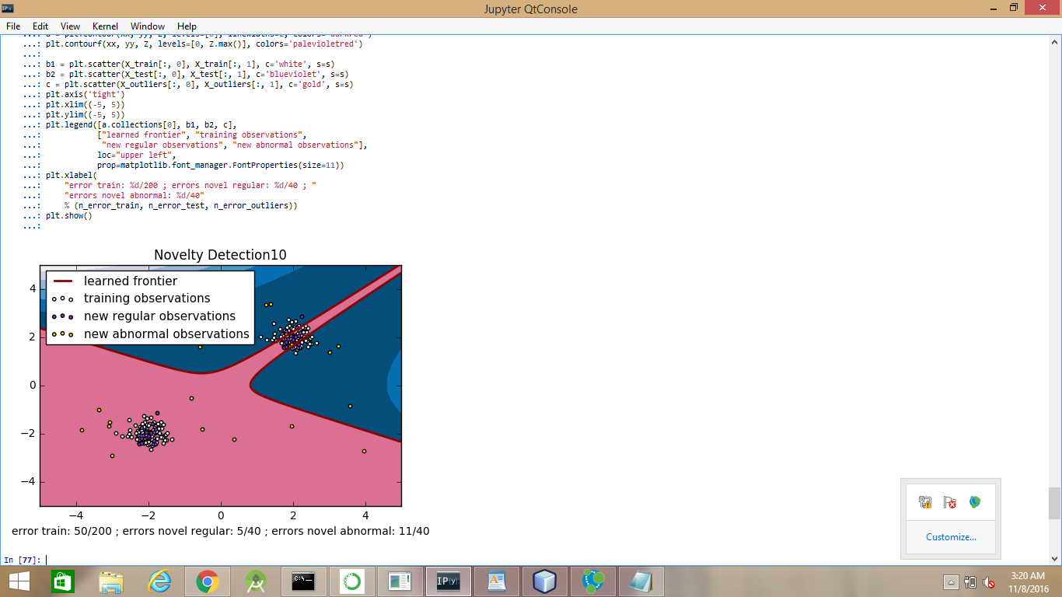

We are taking 40 inputs datasets here and expects a time taken to be around 0 seconds.

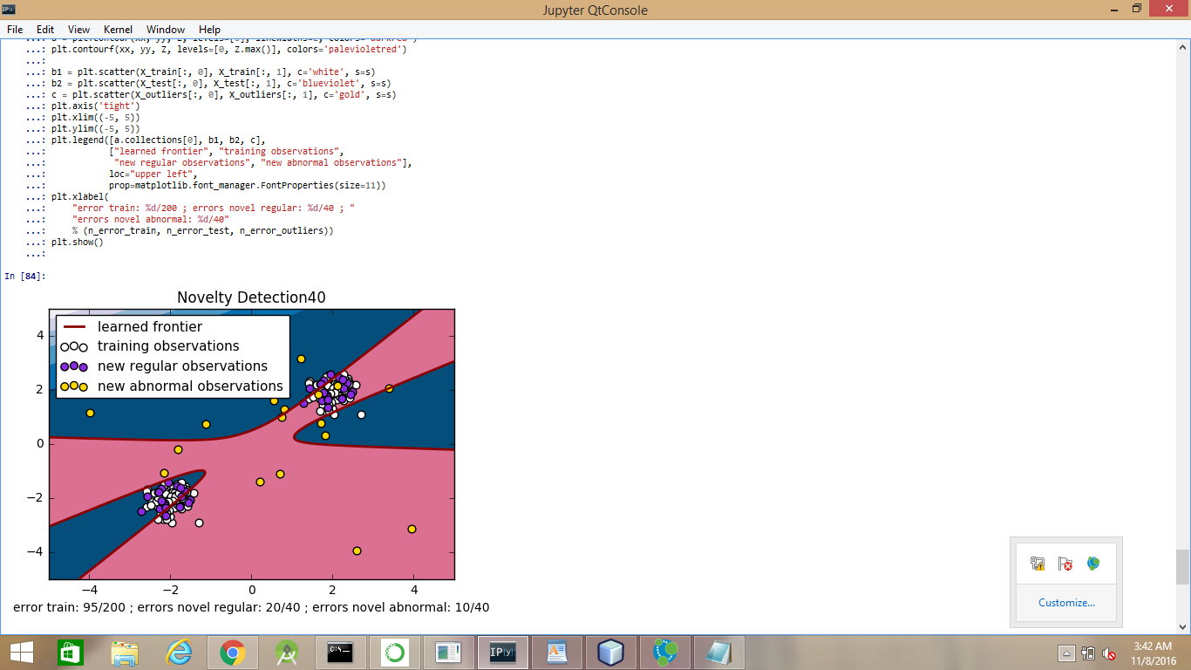

Now we are trying for a fifty degree polynomial:We are taking 10 inputs datasets here and expects a time taken to be around 0 seconds.

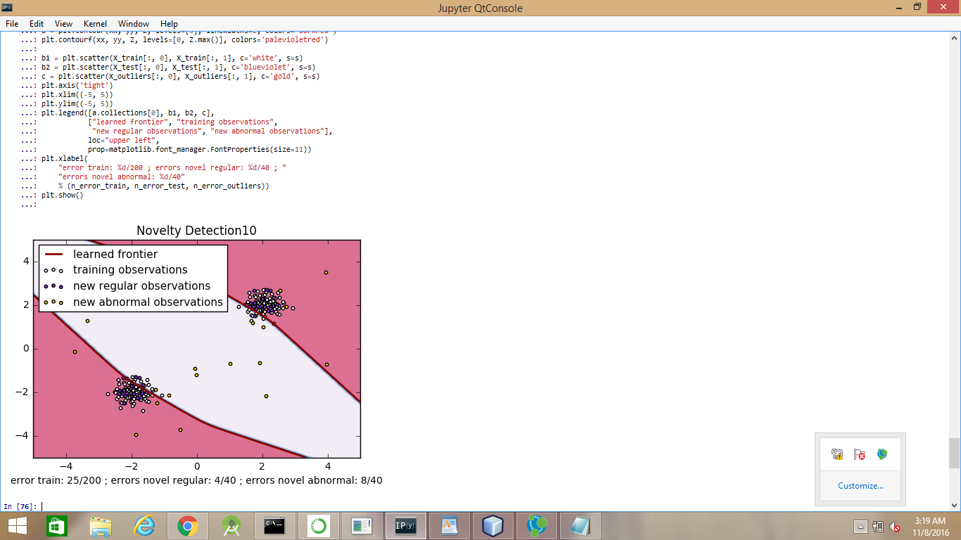

We are taking 20 inputs datasets here and expects a time taken to be around 0 seconds.

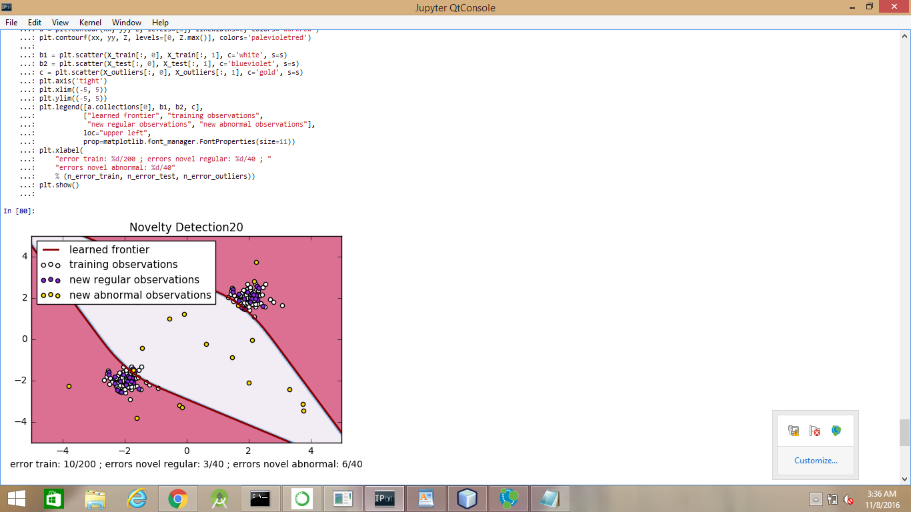

Overall survey of different polynomial functions:

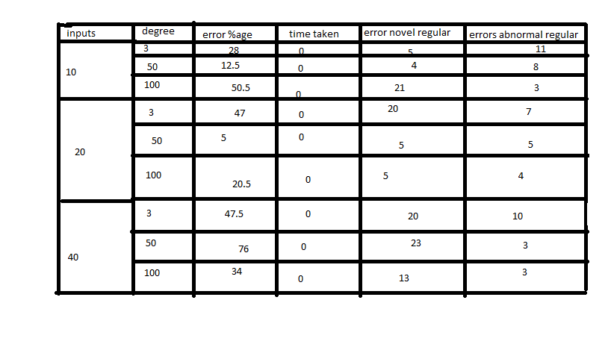

Fig 1: Various kernel polynomial functions in a comparison form showing their experimental results along with time taken.

Comparison among Radial basis function with different input dataset size:

We are taking 10 inputs datasets here and expects a time taken to be around 0 seconds.

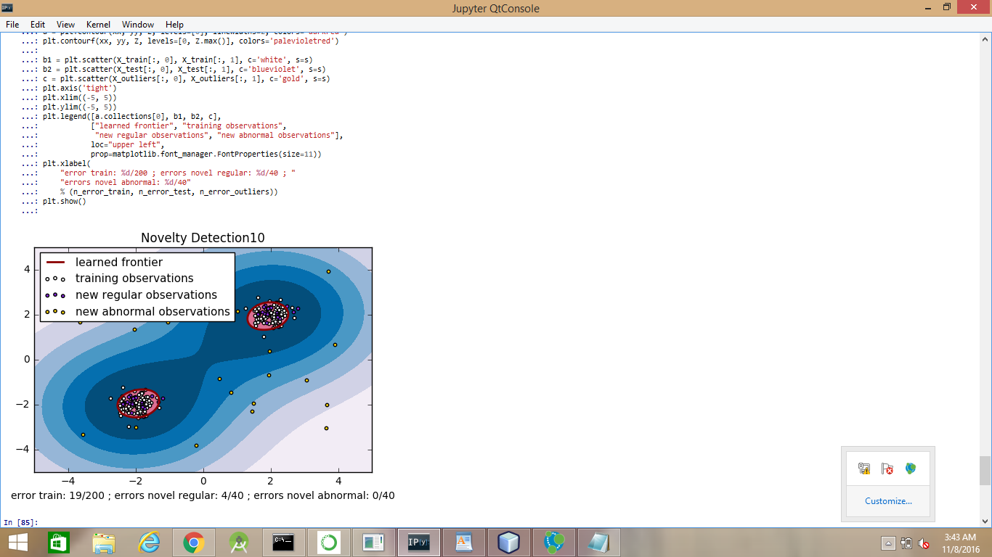

We are taking 20 inputs datasets here and expects a time taken to be around 0 seconds.

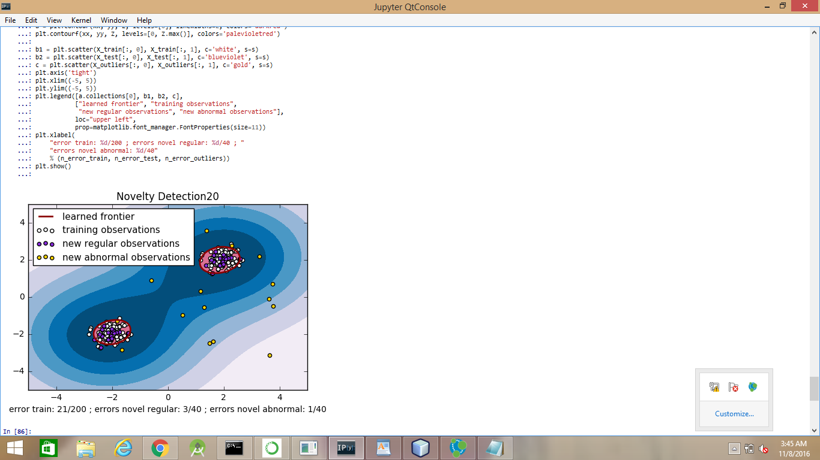

We are taking 40 inputs datasets here and expects a time taken to be around 0 seconds.

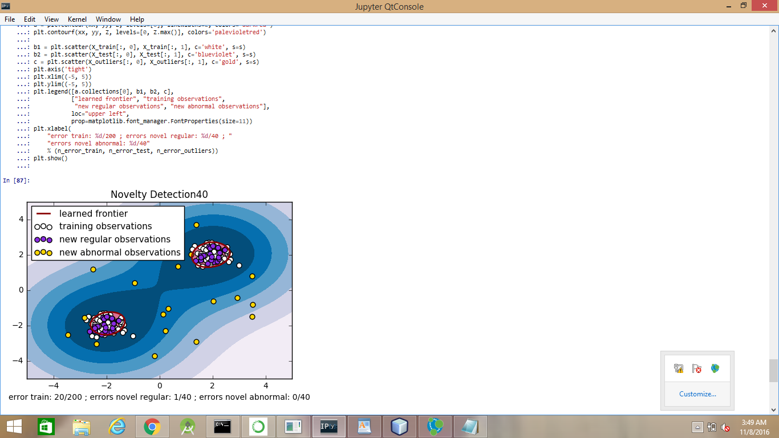

|  |  |  |  |  |  |
| --- | --- | --- | --- | --- | --- |
| Inputs | Error percentage | Time taken | Error Novel regular | Error abnormal regular | |
| 10 | 9.5 | 1 | 4 | | 0 |
| 20 | 10.5 | 1 | 3 | | 1 |
| 40 | 10 | 1 | 1 | | 0 |

FIG 2: Showing the time taken and error percentage by RBF at different dataset size

**6 Experimental Interface**

For a polynomial function in svm classification, higher the number of datasets or inputs and lower the degree ,better the accuracy and lesser the time taken.for a radial basis function in svm classification , time taken will be greater than expectation but accuracy will be far better than polynomial function with the least degree at any cost and at any input dataset size.for a radial basis function in svm classification, lower the number of datasets or inputs , better the accuracy .

.

|  |  |  |  |  |
| --- | --- | --- | --- | --- |
| **Function** | **Error%** | **Time** | **Error novel regular** | **Error abnormal regular** |
| RBF | 9.5 | 1 | 4 | 0 |
| POLY 3 DEGREE | 47.5 | 0 | 20 | 10 |

FIG 3: Comparing best levels of poly 3 kernel function and radial basis kernel function

**7 Conclusion**

Finally in this paper we achieved a summary how the kernel functions come to play in various fields. This comparison will let the next generation writers to make a basic comparison how the kernel functions vary according to their methods. According to our experiment we found the rbf as the most active .Somewhere we got that a polynomial kernel function with lesser degree is giving a better accuracy. This will help a lot in mobile computing where time is a major fact. Many people have given the papers on these kinds of comparison of the kernel functions**[7-10].** We are giving an optimal picture of how this kernel functions can be implemented in case of a polynomial or rbf method argument. But for general view we are concluding that if it's a polynomial function.lesser the degree ,more the input dataset in number ,less the time be taken and more accuracy will be reched but the reverse will play the role in RBF (not the condition given as degree of polynomial).

**References**

1. Hofmann, Martin. "Support vector machines—Kernels and the kernel trick." *Notes* 26 (2006).

2. Howley, Tom, and Michael G. Madden. "The genetic evolution of kernels for support vector machine classifiers." *15th Irish conference on artificial intelligence*. 2004. 3. Research on Kernel Function of Support Vector Machine Lijuan Liu1,2 Bo Shen1,2* Xing Wang3

3. Lin, Hsuan-Tien, and Chih-Jen Lin. "A study on sigmoid kernels for SVM and the training of non-PSD kernels by SMO-type methods." *submitted to Neural Computation* 3 (2003): 1-32.

4. Luss, Ronny, and Alexandre d'Aspremont. "Support vector machine classification with indefinite kernels." *Advances in Neural Information Processing Systems*. 2008.

5. Yekkehkhany, B., et al. "A comparison study of different kernel functions for SVM-based classification of multi-temporal polarimetry SAR data." *The International Archives of Photogrammetry, Remote Sensing and Spatial Information Sciences* 40.2 (2014): 281.

6. Scholkopf, Bernhard, et al. "Comparing support vector machines with Gaussian kernels to radial basis function classifiers." *IEEE transactions on Signal Processing* 45.11 (1997): 2758-2765.

7. Hsu, Chih-Wei, and Chih-Jen Lin. "A comparison of methods for multiclass support vector machines." *IEEE transactions on Neural Networks* 13.2 (2002): 415-425.